

**Advanced Software Engineering**

Course # CSEE 5551 0001

Semester: Spring 2017

LAB Assignment # 3

Submission Date: 2/8/2017

Student Name: Satya Sai Deepthi Katta

Student ID: 16231371

**Instructor:** Dr. Yugyung Lee

**Email:** LeeYu@umkc.edu

**Department of Computer Science & Electrical Engineering**

**University of Missouri, Kansas City**

**Welcome to Lab Assignment #3 Wiki Page!**

Submission on 2/8/17

**Abstract:**

A Web Application is designed to provide a User to Login through social media like Gmail, Facebook. It also provides Client Mashup by using different knowledge services and web services. This application contains Web services Face + + for Face Detection and Inlite for Bar Code Scanning.

**Task 1: Design a UI using a Wireframe Tool**

User Interface are displayed in Wireframes. The tool used for creating Wireframes is creately.com. The website consists of Login page where two OAuth are created to Sign In into the account. The user can simply create account and Sign Up.

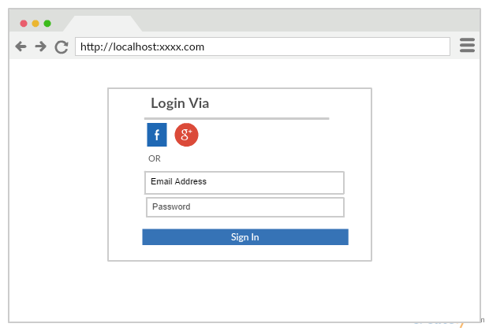

Fig 1. Login Page for the Website presenting two OAuth, Facebook and Gmail

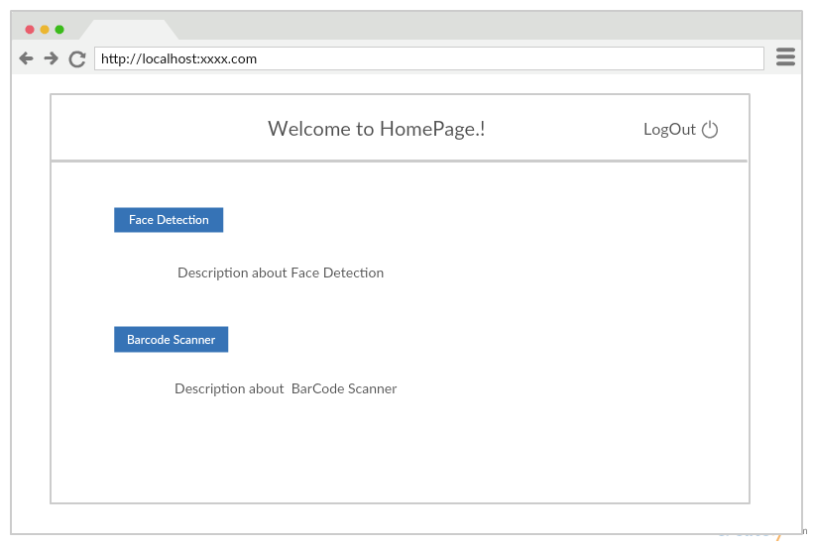

Fig 2. Wireframe showing the Home Page for website where two Mash Up’s are used.

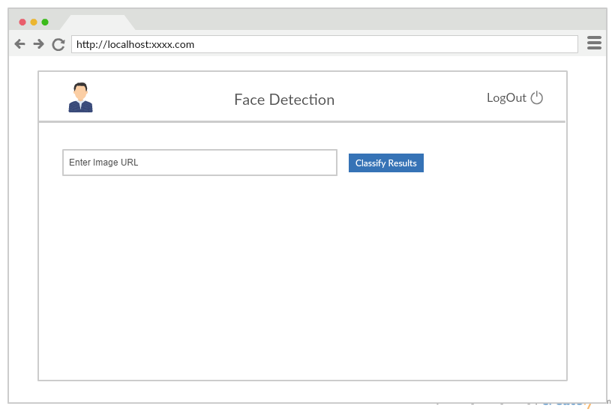

Fig 3. Wireframe for Face Detection Page for the User Interface.

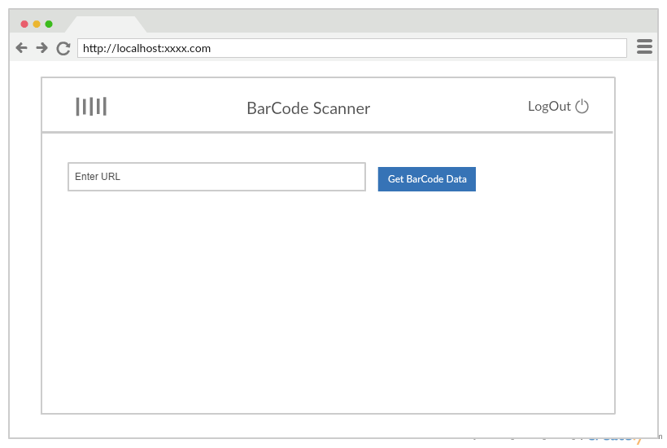

Fig 4. Wireframe for Bar Code Set Up for the UI.

**TASK 2: Create OAuth Login and Registration**

***Login Page:***

OAuth Login are created using the Google Mail and Facebook API’s. The authorization details the account namely username and password to Login into the website. The website displays the Client Mash Up’s.

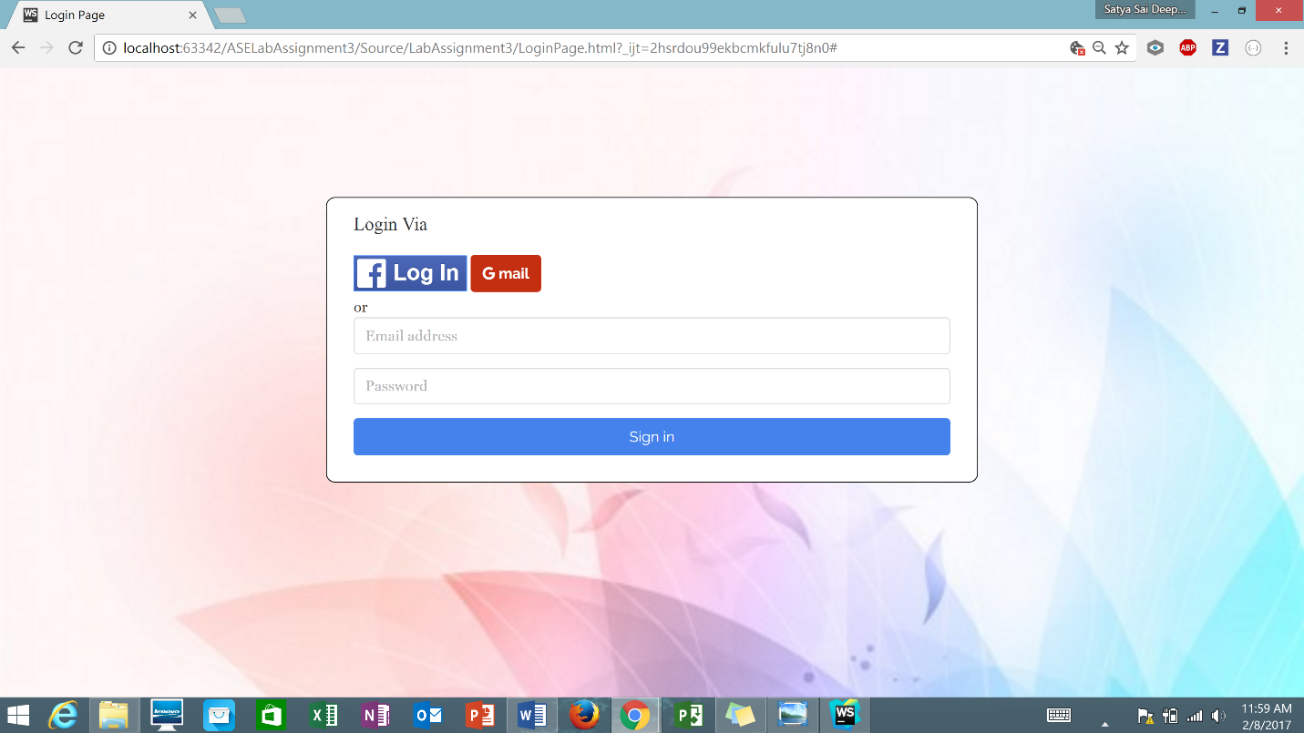

Fig 5. Login Page showing two OAuth Login and registration.

***Facebook Login:***

To login via Facebook Account, the user credentials are needed and when successfully logged in, the website redirects to the Home Page of the Web Application.

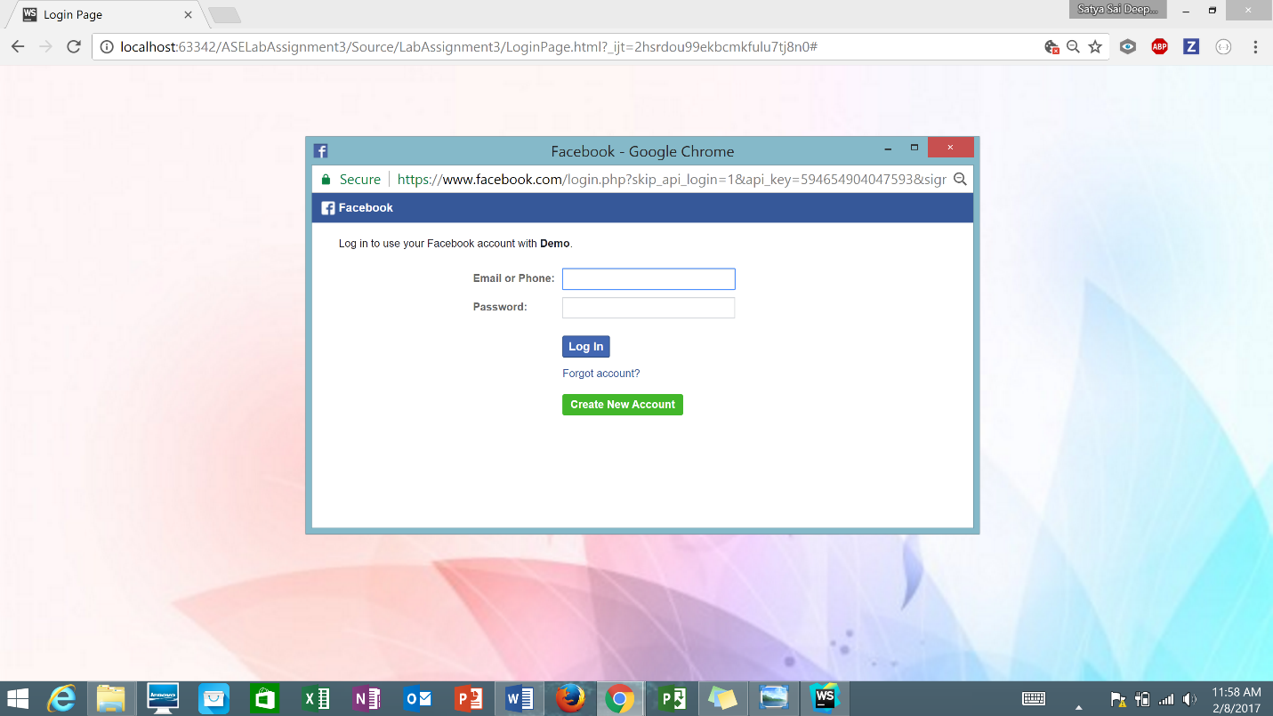Fig 6. OAuth Login for Facebook.

***Gmail Login:***

In order to Login into the account using Google Mail, the user credentials namely username and password are entered.

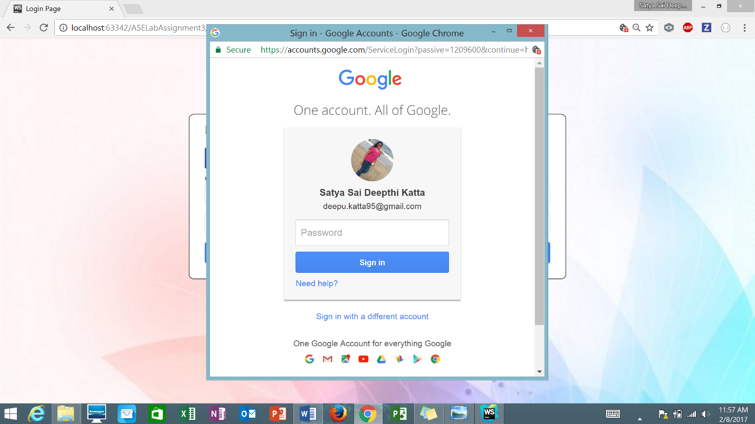Fig 7. OAuth Login for Google Mail.

**TASK 3: Client Side Mash Up**

***Home Page:***

By signing into the account, the website redirects to the Home Page where Client Mash Up’s are displayed. The Home Page provides the different functionalities of the Mashup Applications created using Web services. The links are provided below in the Home page along with some description which explains the functionality of the Applications created.

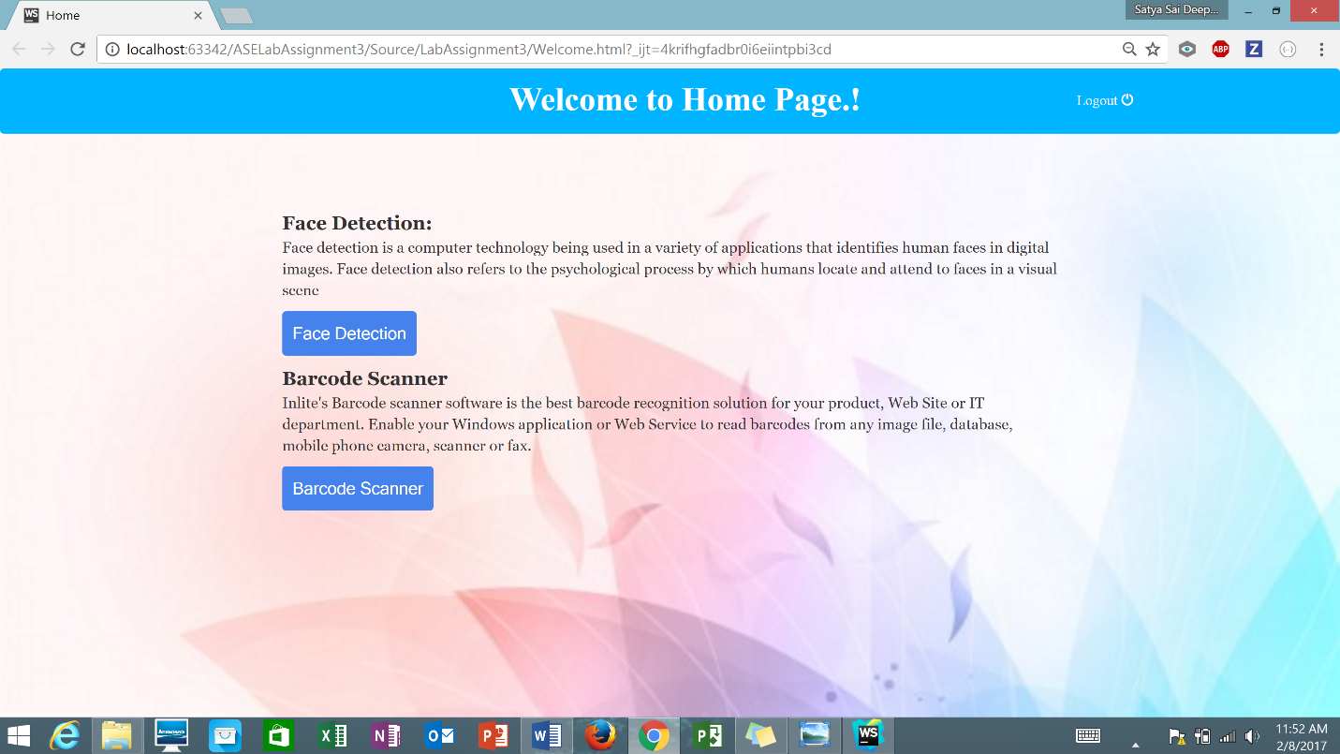

Fig 8. Home Page for the Website displaying Client Mash Up’s.

***Face Detection Page:***

Face Detection functionality has been developed by using Face ++ API.

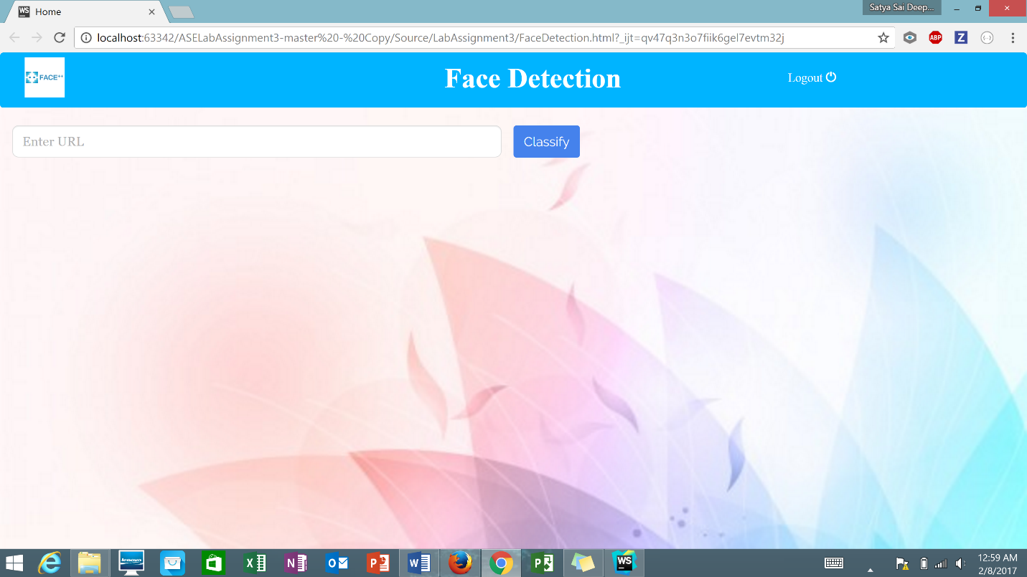

Fig 9. Face Detection Page of the Web Application.

This takes the URL of the Image as input and detects the number of persons in the Image using Facial recognition. In addition to the above feature, this functionality also gives the information about all the people whose are present in the image like Gender, Age, Race and their Smiling Value depicted from the Image.

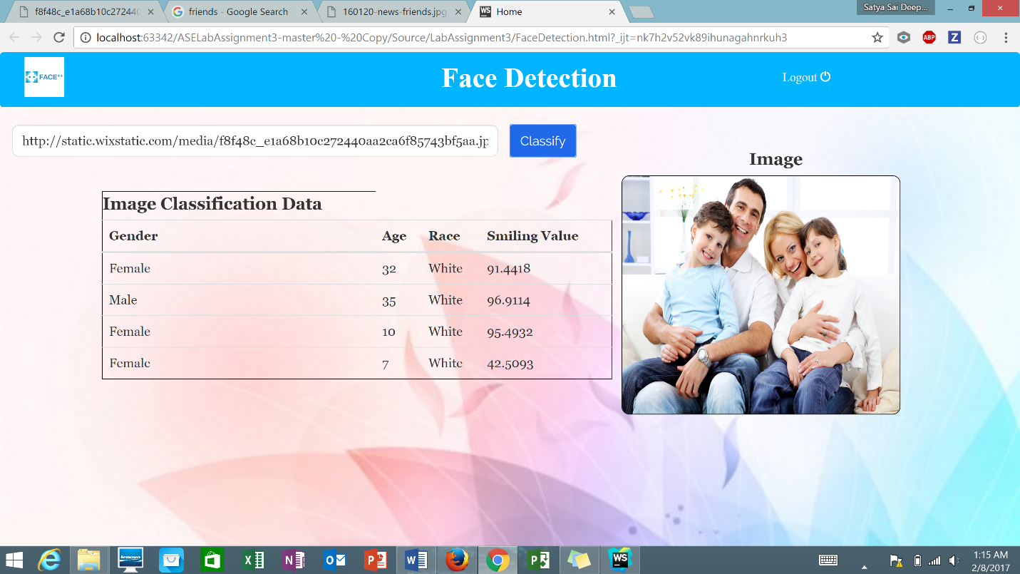

Fig 10. Face Detection results for Image 1.

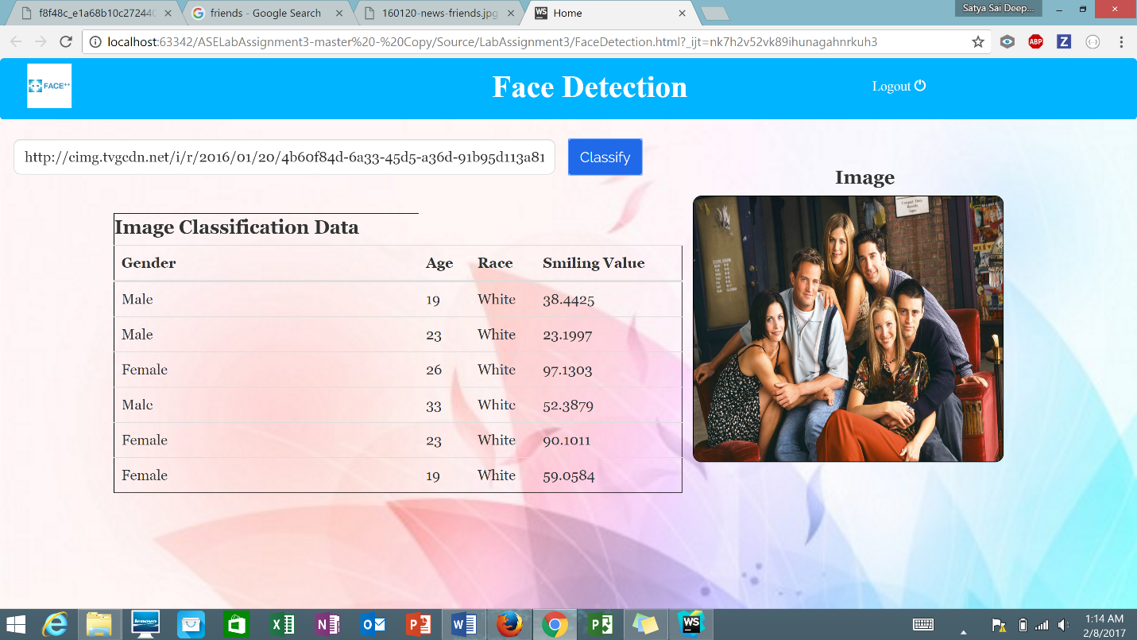

Fig 11. Face Detection results for Image 2.

***Bar Code Scanner Page:***

Barcode Scanning functionality is developed using Inlite API.

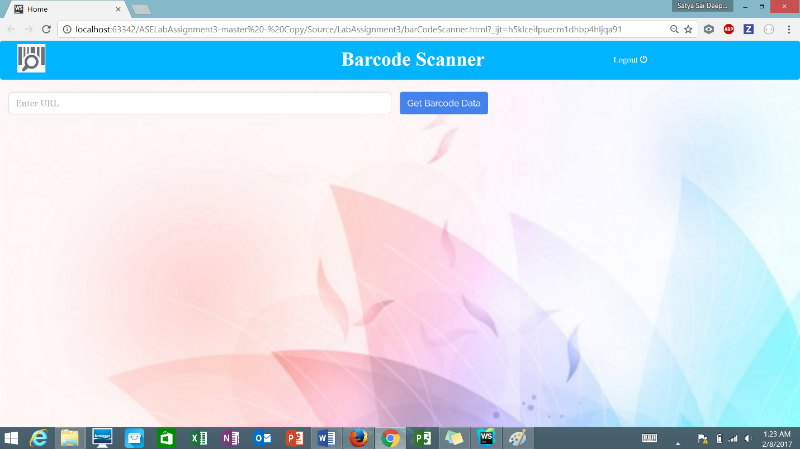

Fig 12. Barcode Scanner Page for Web Application.

Barcode scanner functionality accepts URL of the barcoded image as input and displays the Image on the side. The data relating to the barcode like Text, Data, Type, Length, Page, Rotation, Left, Top, Right, Bottom and File are displayed as the results.

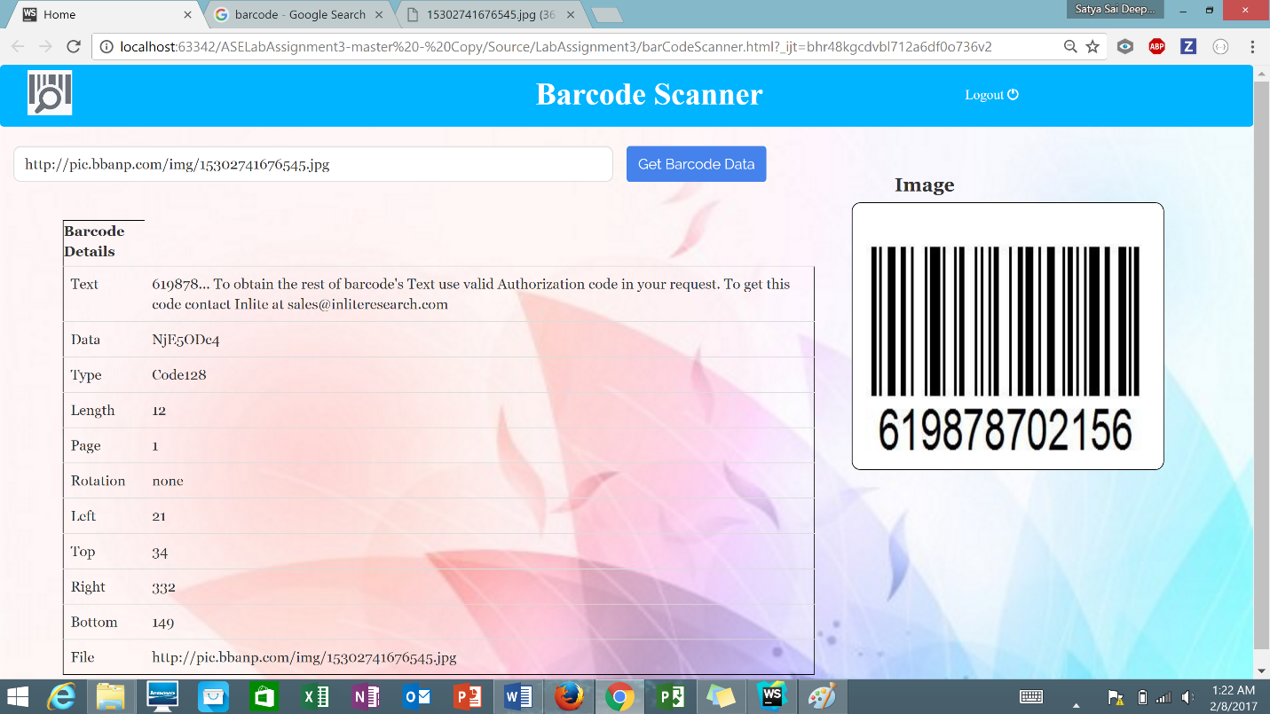

Fig 13. Barcode results for the image inserted.

**TASK 4: Code Quality Analysis Using JSLint**

The java script is copy pasted into the jslint.com to quality check the code for the Web Application.

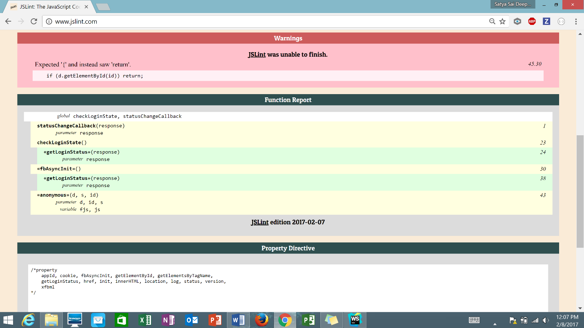Fig 14. Code Quality results for Facebook Login Page.

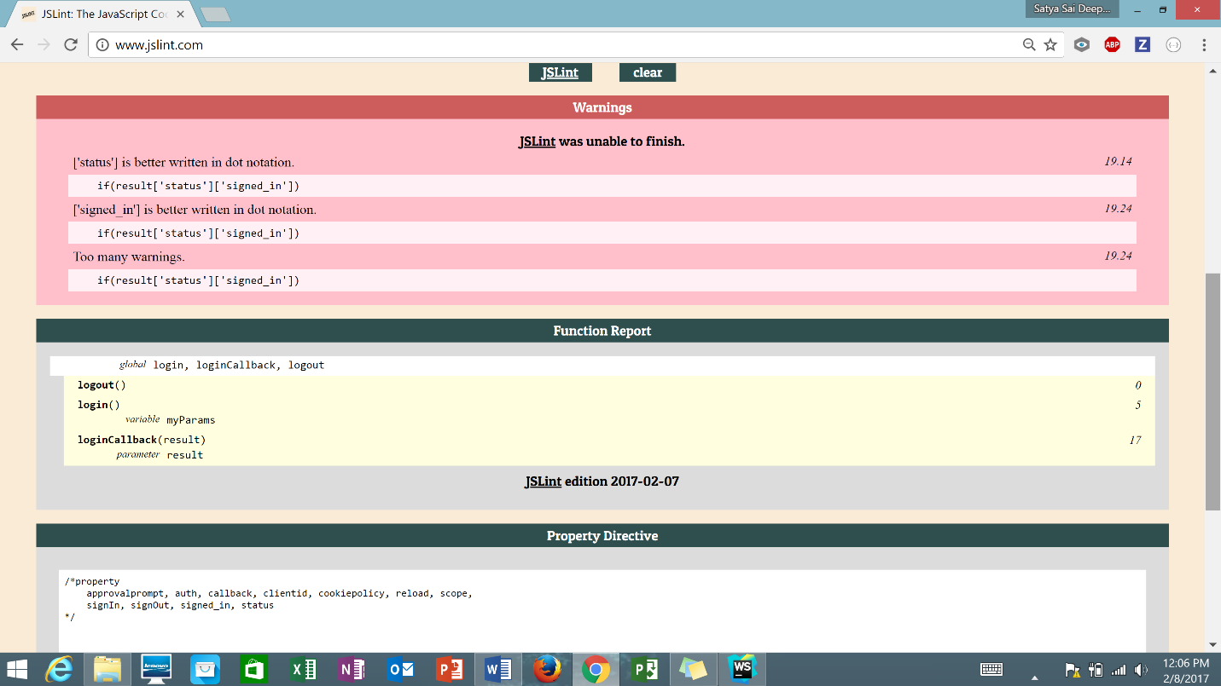

Fig 15. Code Quality results for Gmail Login using JSLint.

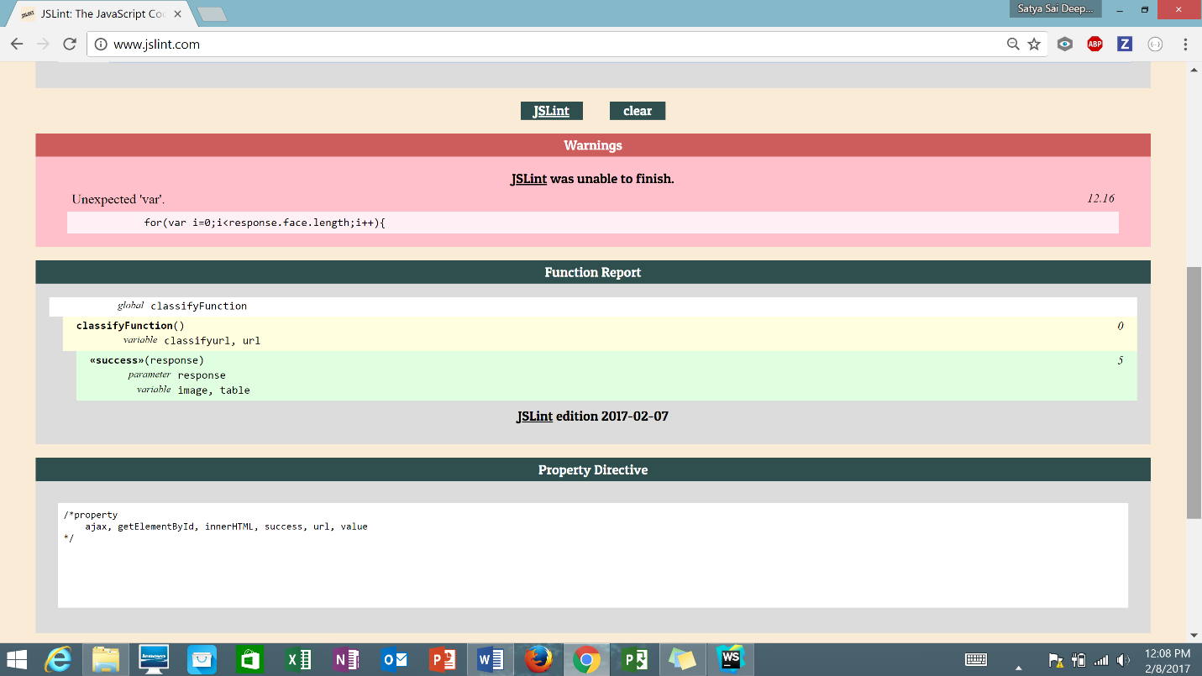

Fig 16. Code Quality results for Face Detection Page using JSLint.

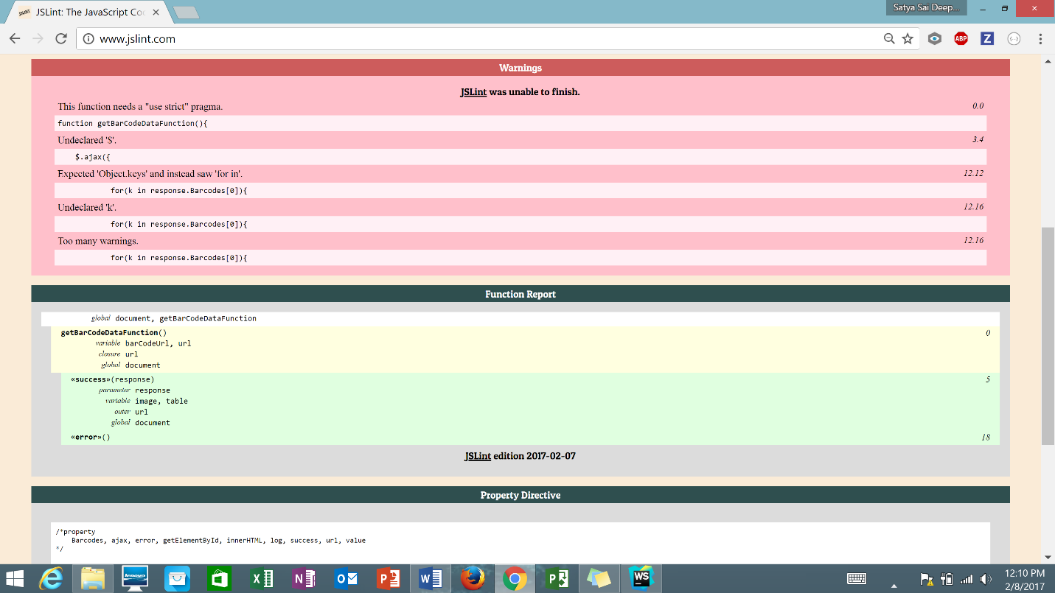

Fig 17. Code Quality results for Barcode Scanner Page using JSLint.

**References:**

<https://developers.facebook.com/>

<https://developers.google.com>

<https://www.faceplusplus.com/>

<http://www.programmableweb.com/api/barcode-scanner>

<http://www.jslint.com/>